W228A/103C, W228B/103C



DUBLIN INSTITUTE OF TECHNOLOGY
_____________

DT228A/1 MSc in Computing
DT228B/1 MSc in Computing
DT228B/2 MSc in Computing
______________

WINTER EXAMINATIONS 2017/2018
______________

Probability and Statistical Inference [Math9102]

Ms. Deirdre Lawless
Dr. Deirdre Lillis
Dr. Ignacio Castiñeiras

Date & Time TBA

Two Hours

Instructions to candidates

Answer question one and one other question.

All questions carry equal marks.

SOLUTIONS

Description of Dataset to be used in All Questions

The General Social Survey(GSS) regularly gathers data on American society to monitor trends in attitudes and behaviours in society. The dataset used in this exam paper is a subset of one year of the GSS. The variables of interest to the questions in this paper are shown in the table below.

Name | Label | Values | Type
AGE | Respondent age |  | Scale
GENDER | Respondent gender | 1 MALE; 2 FEMALE | Nominal
MARTIAL | Marital Status | 1 MARRIED; 2 WIDOWED; 3 DIVORCED; 4 SPEARATED; 5 NEVER MARRIED | Nominal
FAMINCOME | Family Income | Values represent income bands | Scale
HRSWRKD | Hours Worked Last Week |  | Scale
HRSRELAX | Hours Per Day ‎Respondent Has To Relax |  | Scale
i1_immameco | IMMIGRANTS ARE GOOD FOR AMERICA | 1 AGREE STRONGLY; 2 AGREE; 3 NEITHER AGREE or DISAGREE; 4 DISAGREE; 5 DISAGREE STRONGLY | Ordinal
i2_immcult | IMMIGRANTS UNDERMINE AMERICAN CULTURE |  | Ordinal
i3_immideas | IMMIGRANTS MAKE AMERICA MORE OPEN |  | Ordinal
i4_immjobs | IMMIGRANTS TAKE JOBS AWAY |  | Ordinal
i5_immrghts | LEGAL IMMIGRANTS SHOULD HAVE SAME RIGHTS AS AMERICANS |  | Ordinal
i6_excldimm | AMERICA SHOULD EXCLUDE ILLEGAL IMMIGRANTS |  | Ordinal
i7_letin1 | NUMBER OF IMMIGRANTS TO AMERICA NOWADAYS SHOULD BE RESTRICTED |  | Ordinal
i8_meltpot1 | BETTER TO MAINTAIN DISTINCT CULTURES |  | Ordinal

1. | (a) | Providing a statistical summary of the scale variables of interest including a measure central tendency, dispersion and in particular skewness and kurtosis is helpful when presenting a statistical analysis.  Explain each of these concepts and how together what they allow you to describe for variables of interest.  Illustrate your answer by presenting a statistical summary of the variables related to family income, hours per day to relax and hours worked last week using appropriate measures selected from the information provided in Appendix A.  Draw conclusions about their normality.  (18 marks)
Marking Scheme/:
4 x 2 marks for correct explanation of each concept
3 x 3 marks for discussion of each variable
1 mark for concluding about normality
Central tendency: single value that attempts to describe a set of data by identifying the central position within that set of data. Expect brief discussion of Mean, Median, Mode and when to use them.
Dispersion: how the data is dispersed around the central measure; Expect brief discussion of standard deviation, interquartile range, range.
Skewness: measure of the asymmetry of the probability distribution – source of bias; discuss skewness statistic; acceptable range +/-2;
Kurtosis: measure of whether the data are peaked or flat relative to a normal distribution – source of bias; should discuss kurtosis statistic; acceptable range +/-2
Can consider data as normal of 95% of standardised scores fall within +/- 3.27
Should consider skewness and kurtosis of all variables. Should consider standardised score for skew/kurtosis and range of standardised scores of variables. Conclude that despite skewness/kurtosis they are within acceptable ranges. Present mean and standard deviation and conclude that they can be treated as normal.
1. | (b) | Explain what Type I and Type II errors are, how they occur and how to avoid them.  (8 marks)
Marking Scheme:
Type I: incorrect rejection of correct null hypothesis; sample data appear to show an effect/difference when, in fact, there is none in the population 2 marks
Type I caused by unusual, unrepresentative samples 1 mark
Hypothesis test is structured so that Type I errors are very unlikely; the probability of a Type I error is equal to the alpha level so changing alpha level can help avoid 1 mark
Type II: failure to reject null hypothesis; occurs when the sample does not appear to have an effect/difference when in fact this exists in the population 2 marks
Type II commonly the result of a very small effects/differences (not large enough to show up in the research study)1 mark
Increase power of the test to try to avoid – increase the alpha level, increase sample size 1 mark

1. | (c) | Suppose the research team wants to investigate factors that influence family income. Existing research has shown it is influenced by the amount of time a person spends working and their age but that there are differences in income for respondents of different gender and marital status. They now wish to test this theory against the data collected in the GSS.  Explain the steps that you would need to take to develop and test hypotheses related to this theory.  Illustrate your answer by deriving and testing hypotheses related to the team’s theory using the statistics provided in in Appendix A.  Justify your selection of statistical tests based on your answer to part (a).  (24 marks)
Marking Scheme:
Hypothesis testing steps: Derive null and alternate hypotheses; identify type of test needed based on hypothesis; decide on cut-off and critical value; conduct the test to compute test statistic; interpret statistical significance and test statistic; conclude on whether to accept/reject null hypothesis. 4 marks
Alternate Hypotheses (equivalent null hypotheses are expected to be stated in the answer) (4 x 2 marks)
- HA: There is a relationship between a respondent’s age and their family income.
- HA: There is a relationship between the time a respondent spent working last week and their family income.
- HA: There is a difference in family income for respondents of different gender.
- HA: There is a difference in family income for respondents of different marital status
Interpretation of tests (4 x 3 marks)
1. Use Pearson. Significant positive but small @ .134
2. Use Pearson. Significant positive approaching moderate @ .278
3. Use t-test. Not significant. Should look at right line based on homogeneity of variance.
4. Use One way ANOVA. Significant. Should highlight where differences lie. Married and all other categories.

2. | (a) | The research team has decided to further explore the relationship between the family income of a respondent, the hours they worked last week, their age and gender. They have standardised family income, hours worked last week and age. Gender has been recoded as 0 for male and 1 for female. A multiple linear regression model has been created and the relevant statistics are provided in Appendix B.  Explain what linear regression could allow the research team to achieve in terms of their research. In your answer you should clearly explain the following:  - What regression will allow the researcher to do;  - What prediction means in this context;  - Why standardising the scale variables is useful;  - The type of variable used to include gender in the model and why it is needed.  (14 marks)
Marking Scheme:
3 marks explanation of what regression will allow researcher to do
3 marks explanation of what prediction is in this context
2 marks explanation of dummy variable; 2 marks explanation of need for them in this research; 2 marks correct identification of male as reference category; 2 marks for explaining what standardisation does.
Regression will allow researcher to explore how well a set of variables is able to predict an outcome variable; which variable in a set is the best predictor; whether a variable is still able to predict an outcome when controlling for a particular variables.
Prediction: looking at is the variance in the outcome variable and how much of the variance could be considered to be explained by the predictor variables. Should comment on variables involved.
Standardising variables: allows comparison on same scale.
Dummy variable: interested in effect of characteristic, if include 1,2,3,4,5 etc. will act as multiplier, 0 and 1 can see effect and its absence; should address need to recode into multiple variables if multiple categorical values.

2. | (b) | For the model created in part (a):  - Assess the fit and usefulness of the model created.  (12 marks)  - Explain how to interpret the model for male and female respondents.  (10 marks)  In your answer you should state the regression equation, clearly explain any concepts or statistics to which you refer.  Illustrate your answers by using the statistics included in Appendix B.
Marking Scheme:
- 3 x 4 marks explanation and assessment of the coefficients, R2 and F statistic (2 marks explanation 2 marks assessment);
- 4 marks correct statement of equation; 2 x 3 marks correct interpretation of equation for male and female.
F statistic: Whether the model as a whole predicts the dependent variable; Its statistical significance is the significance of the model; Model is significant
Coefficients: Measure the strength and direction of relationships between independent variables and the dependent variance – need to consider the significance of these. Even though the gender variable is not a significant predictor, should recognise need to include it as a control.
R2: the proportion of variance in the outcome (dependent) variable which can be explained by the predictor (independent) variables. An R2 of 1 means the independent variable explains 100% of the variance in the dependent variable. Conversely 0 means it explains none. Adjusted R square – takes account of multiple variables. Model explains 10.2% of variance
Equation: zfamincome=0.205+0.254*Ztvhrswrd+0.92*rgender+0.188*zage (unstandardized),standardised zfamincome=0.205+0.285*Ztvhrswrd+0.054*rgender+0.166*zage
Should illustrate for male and female. Should discuss units of change for other variables.
Model Summary
Model | R | R Square | Adjusted R Square | Std. Error of the Estimate
1 | .328ª | 0.108 | 0.102 | 0.81323684
a. Predictors: (Constant), Zscore: AGE OF RESPONDENT, Zscore: NUMBER OF HOURS WORKED LAST WEEK, GENDER RECODED

ANOVAª
Model |  | Sum of Squares | df | Mean Square | F | Sig.
1 | Regression | 36.743 | 3 | 12.248 | 18.519 | .000^{b}
1 | Residual | 304.703 | 461 | 0.661
1 | Total | 341.446 | 464
a. Dependent Variable: Zscore: TOTAL FAMILY INCOME
b. Predictors: (Constant), Zscore: AGE OF RESPONDENT, Zscore: NUMBER OF HOURS WORKED LAST WEEK, GENDER RECODED

Coefficientsª
Model |  | Unstandardized Coefficients |  | Standardized Coefficients | t | Sig.
 |  | B | Std. Error | Beta | t | Sig.
1 | (Constant) | 0.205 | 0.054 |  | 3.812 | 0.000
1 | Zscore: NUMBER OF HOURS WORKED LAST WEEK | 0.254 | 0.040 | 0.285 | 6.404 | 0.000
1 | GENDER RECODED | 0.092 | 0.076 | 0.054 | 1.204 | 0.229
1 | Zscore: AGE OF RESPONDENT | 0.188 | 0.050 | 0.166 | 3.768 | 0.000
a. Dependent Variable: Zscore: TOTAL FAMILY INCOME

2. | (c) | The research team decided to investigate whether there is an interaction effect between age and gender. They have created a variable IntGenAge, a combination of standardised score for age and gender recoded, and included this in the regression model created for part (b). The output is shown in Appendix B.  - Discuss what an interaction effect is and how it can be assessed using multiple linear regression.  (4 marks)  - Evaluate this model for male and female respondents.  (4 marks)  - Comment on the change in the fit of the model compared to that created in part (a) and how the new term affects the coefficients.  In your answer you should state the regression equation and illustrate your answers by using the statistics included in Appendix B.  (6 marks)
Marking Scheme:
- 2 x 2 marks explanation of interaction and explanation of use of interaction term
- 2 x 2 marks Illustration
- 3 marks for comment on change of fit and on R2 ; 3 marks for comment on coefficients
Expectations of answer:
An interaction occurs when the magnitude of the effect of one independent variable (X) on a dependent variable (Y) varies as a function of a second independent variable (Z).
Add an interaction term to the model – new variable is an interaction term, allows exploration of whether the effect of risk is different for different ages
Improves fit of model, term is statistically significant, should discuss changes in other coefficients.
Comment on significance of model and Adjusted R2.
Comment on change of coefficients and their significance. Neither gender nor interaction are significant.
Equation=0.199+.283*hrswrkd+0.06*gender+0.141*age+0.036 *interaction (standardized)
Equation=0.199+.252*hrswrkd+0.102*gender+0.160*age+0.058 *interaction (unstandardized)
Model Summary
Model | R | R Square | Adjusted R Square | Std. Error of the Estimate
1 | .329ª | 0.108 | 0.101 | 0.81382174
a. Predictors: (Constant), INTERACTION AGE AND GENDER, Zscore: NUMBER OF HOURS WORKED LAST WEEK, GENDER RECODED, Zscore: AGE OF RESPONDENT

ANOVAª
Model |  | Sum of Squares | df | Mean Square | F | Sig.
1 | Regression | 36.967 | 4 | 9.242 | 13.954 | .000^{b}
1 | Residual | 304.479 | 460 | 0.662
1 | Total | 341.446 | 464
a. Dependent Variable: Zscore: TOTAL FAMILY INCOME
b. Predictors: (Constant), INTERACTION AGE AND GENDER, Zscore: NUMBER OF HOURS WORKED LAST WEEK, GENDER RECODED, Zscore: AGE OF RESPONDENT

Coefficientsª
Model |  | Unstandardized Coefficients |  | Standardized Coefficients | t | Sig.
 |  | B | Std. Error | Beta | t | Sig.
1 | (Constant) | 0.199 | 0.054 |  | 3.659 | 0.000
1 | Zscore: NUMBER OF HOURS WORKED LAST WEEK | 0.252 | 0.040 | 0.283 | 6.344 | 0.000
1 | GENDER RECODED | 0.102 | 0.078 | 0.060 | 1.304 | 0.193
1 | Zscore: AGE OF RESPONDENT | 0.160 | 0.069 | 0.141 | 2.313 | 0.021
1 | INTERACTION AGE AND GENDER | 0.058 | 0.100 | 0.036 | 0.581 | 0.561
- Dependent Variable: Zscore: TOTAL FAMILY INCOME
- Equation=0.199+.283*hrswrkd+0.06*gender+0.141*age+0.036 *interaction

3. |  | The research team is interested in respondent’s attitude towards immigration. This is currently assed using eight variables in the dataset resulting from a respondent’s answers to Likert style questions (i1_immameco, i2_immcult, i3_immideas, i4_immjobs, i5_immrghts, i6_excldimm, i7_letin1, i8_meltpot1).  The team want to use Exploratory Factor Analysis to see if it is possible derive a composite score for a respondent’s attitude towards immigration which they could then use as part of a multiple linear regression.  Explain what Exploratory Factor Analysis will allow the research team to achieve.  Discuss the suitability of the dataset for use with this approach.  Illustrate your answer by referring to the statistics included in Appendix C.  You should clearly explain any concepts or statistics to which you refer.  (18 marks)
Marking Scheme:
3 marks objectives; 3 marks use for the research team; 3 marks Sample size and sample to variable ratio (1 for explanation, 2 for interpretation); 5 marks Factorability of the correlation matrix (2 for explanation, 3 for interpretation); 4 marks KMO/Bartlett's (2 for explanation, 2 for interpretation);
Objectives: Reduce the number of variables; Evaluates the construct validity of a scale, test, or instrument; Development of parsimonious (simple) analysis and interpretation; Addresses multicollinearity (two or more variables that are correlated)
EFA Determines the nature of and the number of latent variables that account for observed variation and covariation among set of observed indicators; Used to develop theoretical constructs; Used to prove/disprove proposed theories; only shared variance is used;
Sample size, sample to variable: generally at least 300 cases needed; N:p ratio where N = no of cases, p=no of variables rule of thumb 10:1.
Factorability of the matrix: looking at relationships between individual variables; correlation coefficients >0.30 indicates useful for EFA. Here have correlations for most variables – comment on those that do not correlate -
KMO proportion of variance in variables that might be caused by an underlying factor. High values close to 1 suggest that FA useful, anything less than 0.5 FA won’t be useful. Bartlett tests that variables are correlated. Looking for a statistically significant p value which suggests that they are related and a FA would be useful. No issues for this data.

3. | (b) | Discuss the outcomes of the application of exploratory factor analysis to the dataset and assess its effectiveness for the purposes of the research team.  (20 marks)  In your answers you should clearly explain any concepts or statistics to which you refer. Illustrate your answers by referring to the statistics included in Appendix C.
Marking Scheme:
4 marks correct identification of factors; 4 marks communalities (2 for meaning, 2 for application); 4 marks variance (2 for meaning, 2 for application); 8 marks loadings (4 for meaning, 2 for pre-rotation and 2 for post-rotation);
Extraction: Need to decide how many factors to retain. Criteria for extraction: Kaiser’s criteria (eigenvalue > 1 rule), the Scree test, the cumulative percent of variance extracted.
Communalities: proportion of the common variance within a variable; looking at extraction column
Should look at factor loadings before rotation and after to see differences if any
Rotation: Unrotated results from a factor analysis are not easy to interpret, although the plot helps. Rotation helps clarify and simplify the results of a factor analysis. Conceptually, the axes are being rotated so that the clusters of items fall as closely as possible to them. Making the factor loading pattern much clearer as one of the two pairs of coordinates for each item tends to be close to 0.00
Variance: Looking at total variance explained for factors with eigenvalues > 1;

3. | (c) | Suppose the first factor extracted during exploratory factor analysis has been saved to the dataset as posimm (Positive attitude to immigration) and that the research team has built a multiple linear regression model with this variable as the dependent variable and the standardised scores for family income, age and gender (recoded as 0 and 1) as independent variables.  Assess the fit and usefulness of the model created.  Illustrate your answer by reference to the statistics provided for the variables of interest in Appendix C.  (12 marks)
Marking Scheme:
3 x 4 marks explanation and assessment of the coefficients, R2 and F statistic (2 marks explanation 2 marks assessment);
F statistic: Whether the model as a whole predicts the dependent variable; Its statistical significance is the significance of the model; Model is significant
Coefficients: Measure the strength and direction of relationships between independent variables and the dependent variance – need to consider the significance of these. Even though the gender variable is not a significant predictor, should recognise need to include it as a control.
R2: the proportion of variance in the outcome (dependent) variable which can be explained by the predictor (independent) variables. An R2 of 1 means the independent variable explains 100% of the variance in the dependent variable. Conversely 0 means it explains none. Adjusted R square – takes account of multiple variables. Model explains 5% of variance
Age is not significant predictors, income and gender are.

 | 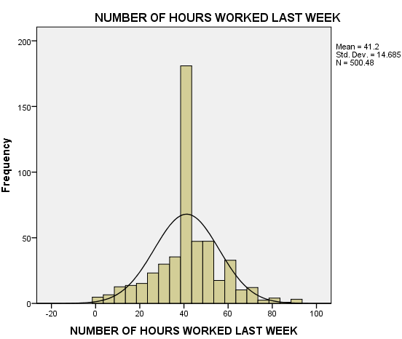
  NUMBER OF HOURS WORKED LAST WEEK |  | HOURS PER DAY ‎RESPONDENT HAS TO RELAX | TOTAL FAMILY INCOME
  N | Valid | 500 | 409 | 702
  N | Missing | 282 | 373 | 80
  Mean |  | 41.20 | 3.39 | 17.75
  Std. Deviation |  | 14.685 | 2.334 | 5.605
  Skewness |  | 0.020 | 1.338 | -1.029
  Std. Error of Skewness |  | 0.109 | 0.121 | 0.092
  Kurtosis |  | 1.058 | 4.183 | 0.704
  Std. Error of Kurtosis |  | 0.218 | 0.241 | 0.184
  Percentiles | 25 | 37.00 | 2.00 | 15.00
  Percentiles | 50 | 40.00 | 3.00 | 19.00
  Percentiles | 75 | 50.00 | 5.00 | 22.00
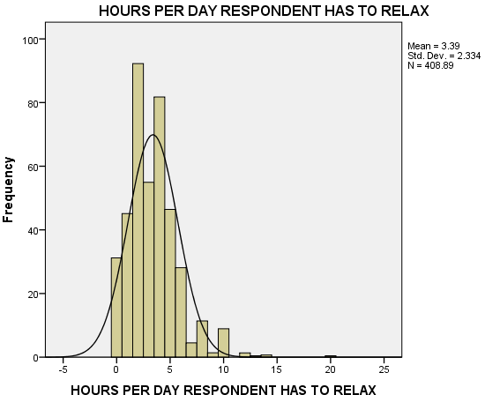 | 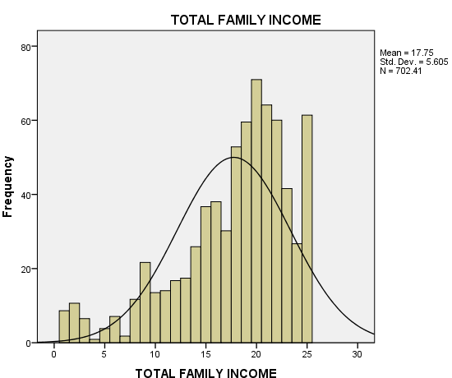

Zscore TOTAL FAMILY INCOME Stem-and-Leaf Plot  Frequency Stem & Leaf  8.38 Extremes (=<-2.1)  1.34 -1 . 99  3.14 -1 . 7777  8.79 -1 . 55555555555  12.82 -1 . 2222223333333333  9.97 -1 . 000000000000  6.96 -0 . 888888888  9.28 -0 . 666666666666  19.93 -0 . 4444444444444444444444444  22.00 -0 . 333333333333333333333333333  13.38 -0 . 11111111111111111  34.00 0 . 000000000000000000000000000000000000000000  28.96 0 . 222222222222222222222222222222222222  80.15 0 . 4444444444444444444444444444444444444444444444444  444444444455555555555555555555555555555555555555555  36.52 0 . 7777777777777777777777777777777777  777777777777  24.93 0 . 9999999999999999999999999999999  12.34 1 . 111111111111111  49.67 1 . 2222222222222222222222222222222222222222222222222  2222222222222  Stem width: 1.00000 Each leaf: .80 case(s) | Zscore NUMBER OF HOURS WORKED LAST WEEK Stem-and-Leaf Plot  Frequency Stem & Leaf  24.76 Extremes (=<-1.7)  10.00 -1 . 44444&  1.83 -1 . 2  11.93 -1 . 000011  10.41 -0 . 888899  21.93 -0 . 66677777777  10.83 -0 . 44445  18.49 -0 . 222333333  131.89 -0 . 111111111111111111111111111111111111111111111111111111111111111111&  7.00 0 . 001  24.07 0 . 222222222222&  36.69 0 . 444555555555555555  6.59 0 . 666  12.07 0 . 888889  3.86 1 . 00  26.80 1 . 2222222222222  3.86 1 . 55  .90 1 . &  18.66 Extremes (>=1.9)  Stem width: 1.00000  Each leaf: 2 case(s)  & denotes fractional leaves.
Zscore HOURS PER DAY ‎RESPONDENT HAS TO RELAX Stem-and-Leaf Plot
Frequency Stem & Leaf
31.18 -1 . 44444444444444444444444444444444444444
42.87 -1 . 00000000000000000000000000000000000000000000
00000000
83.59 -0 . 6666666666666666666666666666666666666666666666666
6666666666666666666666666666666666666666666666666666
52.72 -0 . 111111111111111111111111111111111111111111111
1111111111111111111
79.07 0 . 222222222222222222222222222222222222222222222
222222222222222222222222222222222222222222222222222
41.66 0 . 66666666666666666666666666666666666666666666666666
22.38 1 . 000000000000000000000000000
4.48 1 . 44444
24.63 Extremes (>=1.9)
Stem width: 1.00000 Each leaf: .83 case(s)

Pearson
  AGE OF RESPONDENT |  | TOTAL FAMILY INCOME | NUMBER OF HOURS WORKED LAST WEEK
  AGE OF RESPONDENT | Pearson Correlation | 1 | .134** | 0.038
  AGE OF RESPONDENT | Sig. (2-tailed) |  | 0.000 | 0.394
  AGE OF RESPONDENT | N | 781 | 702 | 500
  TOTAL FAMILY INCOME | Pearson Correlation | .134** | 1 | .278**
  TOTAL FAMILY INCOME | Sig. (2-tailed) | 0.000 |  | 0.000
  TOTAL FAMILY INCOME | N | 702 | 702 | 465
  NUMBER OF HOURS WORKED LAST WEEK | Pearson Correlation | 0.038 | .278** | 1
  NUMBER OF HOURS WORKED LAST WEEK | Sig. (2-tailed) | 0.394 | 0.000
  NUMBER OF HOURS WORKED LAST WEEK | N | 500 | 465 | 500
  **. Correlation is significant at the 0.01 level (2-tailed).
  Spearman's Rho |  | AGE OF RESPONDENT | TOTAL FAMILY INCOME | NUMBER OF HOURS WORKED LAST WEEK
  AGE OF RESPONDENT | Correlation Coefficient | 1.000 | .164** | 0.056
  AGE OF RESPONDENT | Sig. (2-tailed) |  | 0.000 | 0.236
  AGE OF RESPONDENT | N | 692 | 621 | 449
  TOTAL FAMILY INCOME | Correlation Coefficient | .164** | 1.000 | .270**
  TOTAL FAMILY INCOME | Sig. (2-tailed) | 0.000 |  | 0.000
  TOTAL FAMILY INCOME | N | 621 | 621 | 420
  NUMBER OF HOURS WORKED LAST WEEK | Correlation Coefficient | 0.056 | .270** | 1.000
  NUMBER OF HOURS WORKED LAST WEEK | Sig. (2-tailed) | 0.236 | 0.000
  NUMBER OF HOURS WORKED LAST WEEK | N | 449 | 420 | 450
Group Statistics
RESPONDENTS SEX |  | N | Mean | Std. Deviation | Std. Error Mean
TOTAL FAMILY INCOME | MALE | 321 | 17.94 | 5.491 | 0.306
TOTAL FAMILY INCOME | FEMALE | 381 | 17.59 | 5.701 | 0.292

Independent Samples Test
 |  | Levene's Test for Equality of Variances |  | t-test for Equality of Means
 |  | F | Sig. | t | df | Sig. (2-tailed) | Mean Difference | Std. Error Difference | 95% Confidence Interval of the Difference
 |  |  |  |  |  |  |  |  | Lower | Upper
TOTAL FAMILY INCOME | Equal variances assumed | 0.473 | 0.492 | 0.837 | 700 | 0.403 | 0.355 | 0.425 | -0.478 | 1.189
TOTAL FAMILY INCOME | Equal variances not assumed |  |  | 0.840 | 688.183 | 0.401 | 0.355 | 0.423 | -0.475 | 1.186

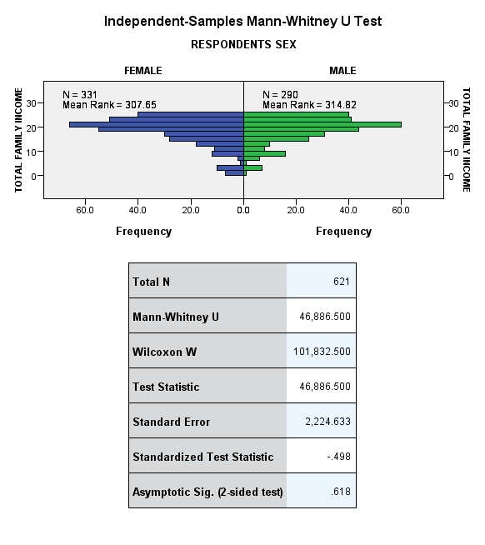 | 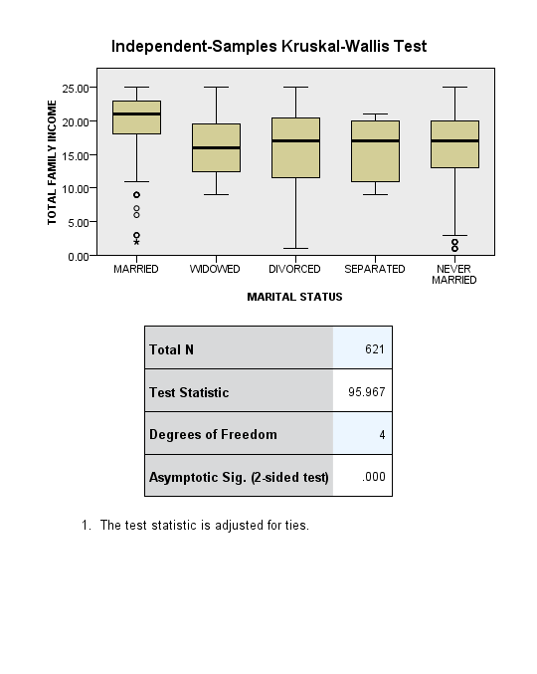

ANOVA
  TOTAL FAMILY INCOME
  Mean SquareFSig.
  Between GroupsSum of Squaresdf | 3639.798 | 4 | 909.949 | 34.483 | 0.000
  Within Groups | 18392.726 | 697 | 26.388
  Total | 22032.523 | 701
  Multiple Comparisons
  Dependent Variable:
  Tukey HSD
  (I) MARITAL STATUS |  | Mean Difference (I-J) | Std. Error | Sig. | 95% Confidence Interval
   |  |  |  |  | Lower Bound | Upper Bound
  MARRIED | WIDOWED | 4.297* | 0.878 | 0.000 | 1.90 | 6.70
  MARRIED | DIVORCED | 4.143* | 0.575 | 0.000 | 2.57 | 5.72
  MARRIED | SEPARATED | 5.622* | 1.495 | 0.002 | 1.53 | 9.71
  MARRIED | NEVER MARRIED | 4.718* | 0.462 | 0.000 | 3.45 | 5.98
  WIDOWED | MARRIED | -4.297* | 0.878 | 0.000 | -6.70 | -1.90
  WIDOWED | DIVORCED | -0.154 | 0.978 | 1.000 | -2.83 | 2.52
  WIDOWED | SEPARATED | 1.325 | 1.691 | 0.935 | -3.30 | 5.95
  WIDOWED | NEVER MARRIED | 0.421 | 0.915 | 0.991 | -2.08 | 2.93
  DIVORCED | MARRIED | -4.143* | 0.575 | 0.000 | -5.72 | -2.57
  DIVORCED | WIDOWED | 0.154 | 0.978 | 1.000 | -2.52 | 2.83
  DIVORCED | SEPARATED | 1.479 | 1.556 | 0.877 | -2.78 | 5.73
  DIVORCED | NEVER MARRIED | 0.575 | 0.631 | 0.893 | -1.15 | 2.30
  SEPARATED | MARRIED | -5.622* | 1.495 | 0.002 | -9.71 | -1.53
  SEPARATED | WIDOWED | -1.325 | 1.691 | 0.935 | -5.95 | 3.30
  SEPARATED | DIVORCED | -1.479 | 1.556 | 0.877 | -5.73 | 2.78
  SEPARATED | NEVER MARRIED | -0.904 | 1.517 | 0.976 | -5.05 | 3.25
  NEVER MARRIED | MARRIED | -4.718* | 0.462 | 0.000 | -5.98 | -3.45
  NEVER MARRIED | WIDOWED | -0.421 | 0.915 | 0.991 | -2.93 | 2.08
  NEVER MARRIED | DIVORCED | -0.575 | 0.631 | 0.893 | -2.30 | 1.15
  NEVER MARRIED | SEPARATED | 0.904 | 1.517 | 0.976 | -3.25 | 5.05
  *. The mean difference is significant at the 0.05 level.

  Model Summary
  Model | R | R Square | Adjusted R Square | Std. Error of the Estimate
  1 | .328ª | 0.108 | 0.102 | 0.81323684
  a. Predictors: (Constant), Zscore: AGE OF RESPONDENT, Zscore: NUMBER OF HOURS WORKED LAST WEEK, GENDER RECODED
  ANOVAª
  Model |  | Sum of Squares | df | Mean Square | F | Sig.
  1 | Regression | 36.743 | 3 | 12.248 | 18.519 | .000^{b}
  1 | Residual | 304.703 | 461 | 0.661
  1 | Total | 341.446 | 464
  a. Dependent Variable: Zscore: TOTAL FAMILY INCOME
  b. Predictors: (Constant), Zscore: AGE OF RESPONDENT, Zscore: NUMBER OF HOURS WORKED LAST WEEK, GENDER RECODED
Coefficientsª
Model |  | Unstandardized Coefficients |  | Standardized Coefficients | t | Sig.
 |  | B | Std. Error | Beta | t | Sig.
1 | (Constant) | 0.205 | 0.054 |  | 3.812 | 0.000
1 | Zscore: NUMBER OF HOURS WORKED LAST WEEK | 0.254 | 0.040 | 0.285 | 6.404 | 0.000
1 | GENDER RECODED | 0.092 | 0.076 | 0.054 | 1.204 | 0.229
1 | Zscore: AGE OF RESPONDENT | 0.188 | 0.050 | 0.166 | 3.768 | 0.000
a. Dependent Variable: Zscore: TOTAL FAMILY INCOME

  Model Summary
  Model | R | R Square | Adjusted R Square | Std. Error of the Estimate
  1 | .329ª | 0.108 | 0.101 | 0.81382174
  a. Predictors: (Constant), INTERACTION AGE AND GENDER, Zscore: NUMBER OF HOURS WORKED LAST WEEK, GENDER RECODED, Zscore: AGE OF RESPONDENT
  ANOVAª
  Model |  | Sum of Squares | df | Mean Square | F | Sig.
  1 | Regression | 36.967 | 4 | 9.242 | 13.954 | .000^{b}
  1 | Residual | 304.479 | 460 | 0.662
  1 | Total | 341.446 | 464
  a. Dependent Variable: Zscore: TOTAL FAMILY INCOME
  b. Predictors: (Constant), INTERACTION AGE AND GENDER, Zscore: NUMBER OF HOURS WORKED LAST WEEK, GENDER RECODED, Zscore: AGE OF RESPONDENT
Coefficientsª
Model |  | Unstandardized Coefficients |  | Standardized Coefficients | t | Sig.
 |  | B | Std. Error | Beta | t | Sig.
1 | (Constant) | 0.199 | 0.054 |  | 3.659 | 0.000
1 | Zscore: NUMBER OF HOURS WORKED LAST WEEK | 0.252 | 0.040 | 0.283 | 6.344 | 0.000
1 | GENDER RECODED | 0.102 | 0.078 | 0.060 | 1.304 | 0.193
1 | Zscore: AGE OF RESPONDENT | 0.160 | 0.069 | 0.141 | 2.313 | 0.021
1 | INTERACTION AGE AND GENDER | 0.058 | 0.100 | 0.036 | 0.581 | 0.561
a. Dependent Variable: Zscore: TOTAL FAMILY INCOME

** significant at p <.001, * significant at p <0.05
  Correlation Matrixª
   |  | IMMIGRANTS GOOD FOR AMERICA | IMMIGRANTS UNDERMINE AMERICAN CULTURE | IMMIGRANTS MAKE AMERICA MORE OPEN | IMMIGRANTS TAKE JOBS AWAY | LEGAL IMMIGRANTS SHOULD HAVE SAME RIGHTS AS AMERICANS | AMERICA SHOULD EXCLUDE ILLEGAL IMMIGRANTS | NUMBER OF IMMIGRANTS TO AMERICA NOWADAYS SHOULD BE RESTRICTED | BETTER TO MAINTAIN DISTINCT CULTURES
  Correlation | IMMIGRANTS GOOD FOR AMERICA | 1.000 | -0.283** | 0.588** | -0.489** | 0.239** | -0.247** | 0.405** | 0.129*
  Correlation | IMMIGRANTS UNDERMINE AMERICAN CULTURE | -0.283** | 1.000 | -0.281** | 0.363** | -0.067 | 0.176** | -0.221** | -0.137*
  Correlation | IMMIGRANTS MAKE AMERICA MORE OPEN | 0.588** | -0.281** | 1.000 | -0.443** | 0.244** | -0.282** | 0.429** | 0.093
  Correlation | IMMIGRANTS TAKE JOBS AWAY | -0.489** | 0.363** | -0.443** | 1.000 | -0.180** | 0.273** | -0.357** | -0.083
  Correlation | LEGAL IMMIGRANTS SHOULD HAVE SAME RIGHTS AS AMERICANS | 0.239** | -0.067 | 0.244** | -0.180** | 1.000 | -0.303** | 0.273** | 0.136**
  Correlation | AMERICA SHOULD EXCLUDE ILLEGAL IMMIGRANTS | -0.247** | 0.176** | -0.282** | 0.273** | -0.303** | 1.000 | -0.336** | -0.245**
  Correlation | NUMBER OF IMMIGRANTS TO AMERICA NOWADAYS SHOULD BE RESTRICTED | 0.405** | -0.221** | 0.429** | -0.357** | 0.273** | -0.336** | 1.000 | 0.125*
  Correlation | BETTER TO MAINTAIN DISTINCT CULTURES | 0.129* | -0.137* | 0.093 | -0.083 | 0.136** | -0.245** | 0.125* | 1.000
  Determinant = .204_{a}
  KMO and Bartlett's Test
  Kaiser-Meyer-Olkin Measure of Sampling Adequacy. |  | 0.815
  Bartlett's Test of Sphericity | Approx. Chi-Square | 464.112
  Bartlett's Test of Sphericity | df | 28
  Bartlett's Test of Sphericity | Sig. | 0.000
 | 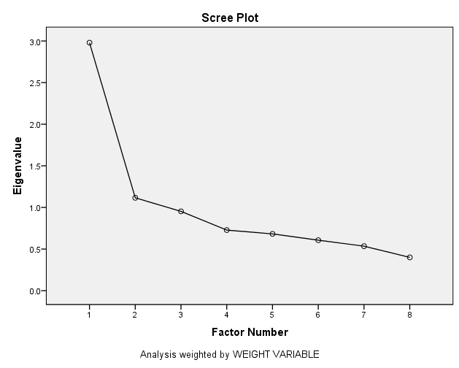
  Communalities
   | Initial | Extraction
  IMMIGRANTS GOOD FOR AMERICA | 0.432 | 0.582
  IMMIGRANTS UNDERMINE AMERICAN CULTURE | 0.168 | 0.173
  IMMIGRANTS MAKE AMERICA MORE OPEN | 0.420 | 0.540
  IMMIGRANTS TAKE JOBS AWAY | 0.340 | 0.425
  LEGAL IMMIGRANTS SHOULD HAVE SAME RIGHTS AS AMERICANS | 0.146 | 0.194
  AMERICA SHOULD EXCLUDE ILLEGAL IMMIGRANTS | 0.220 | 0.515
  NUMBER OF IMMIGRANTS TO AMERICA NOWADAYS SHOULD BE RESTRICTED | 0.286 | 0.356
  BETTER TO MAINTAIN DISTINCT CULTURES | 0.077 | 0.107
  Extraction Method: Principal Axis Factoring.
Total Variance Explained
Factor | Initial Eigenvalues |  |  | Extraction Sums of Squared Loadings |  |  | Rotation Sums of Squared Loadings
Factor | Total | % of Variance | Cumulative % | Total | % of Variance | Cumulative % | Total | % of Variance | Cumulative %
1 | 2.980 | 37.248 | 37.248 | 2.417 | 30.212 | 30.212 | 1.896 | 23.696 | 23.696
2 | 1.116 | 13.948 | 51.196 | 0.476 | 5.950 | 36.162 | 0.997 | 12.466 | 36.162
3 | 0.953 | 11.912 | 63.108
4 | 0.728 | 9.101 | 72.209
5 | 0.682 | 8.525 | 80.734
6 | 0.607 | 7.582 | 88.316
7 | 0.535 | 6.685 | 95.001
8 | 0.400 | 4.999 | 100.000
Extraction Method: Principal Axis Factoring.

  Factor Matrixª
   | Factor
   | 1 | 2
  IMMIGRANTS GOOD FOR AMERICA | 0.725 | 0.236
  IMMIGRANTS UNDERMINE AMERICAN CULTURE | -0.407 | -0.086
  IMMIGRANTS MAKE AMERICA MORE OPEN | 0.712 | 0.182
  IMMIGRANTS TAKE JOBS AWAY | -0.633 | -0.159
  LEGAL IMMIGRANTS SHOULD HAVE SAME RIGHTS AS AMERICANS | 0.377 | -0.228
  AMERICA SHOULD EXCLUDE ILLEGAL IMMIGRANTS | -0.522 | 0.492
  NUMBER OF IMMIGRANTS TO AMERICA NOWADAYS SHOULD BE RESTRICTED | 0.593 | -0.066
  BETTER TO MAINTAIN DISTINCT CULTURES | 0.226 | -0.237
  Extraction Method: Principal Axis Factoring.
  a. 2 factors extracted. 25 iterations required.
  Rotated Factor Matrixª
   | Factor
   | 1 | 2
  IMMIGRANTS GOOD FOR AMERICA | 0.743 | 0.174
  IMMIGRANTS UNDERMINE AMERICAN CULTURE | -0.393 | -0.138
  IMMIGRANTS MAKE AMERICA MORE OPEN | 0.703 | 0.214
  IMMIGRANTS TAKE JOBS AWAY | -0.623 | -0.192
  LEGAL IMMIGRANTS SHOULD HAVE SAME RIGHTS AS AMERICANS | 0.205 | 0.390
  AMERICA SHOULD EXCLUDE ILLEGAL IMMIGRANTS | -0.192 | -0.691
  NUMBER OF IMMIGRANTS TO AMERICA NOWADAYS SHOULD BE RESTRICTED | 0.473 | 0.364
  BETTER TO MAINTAIN DISTINCT CULTURES | 0.070 | 0.320
  Extraction Method: Principal Axis Factoring.
  Rotation Method: Varimax with Kaiser Normalization.
  a. Rotation converged in 3 iterations.

  Model Summary
  Model | R | R Square | Adjusted R Square | Std. Error of the Estimate
  1 | .251ª | 0.063 | 0.053 | 0.83110348
  a. Predictors: (Constant), Zscore: AGE OF RESPONDENT, GENDER RECODED, Zscore: TOTAL FAMILY INCOME
  ANOVAª
  Model |  | Sum of Squares | df | Mean Square | F | Sig.
  1 | Regression | 12.361 | 3 | 4.120 | 5.965 | .001^{b}
  1 | Residual | 183.533 | 266 | 0.691
  1 | Total | 195.894 | 269
  a. Dependent Variable: POSITIVE ATTITUDE TO IMMIGRATION
  b. Predictors: (Constant), Zscore: AGE OF RESPONDENT, GENDER RECODED, Zscore: TOTAL FAMILY INCOME
Coefficientsª
Model |  | Unstandardized Coefficients |  | Standardized Coefficients | t | Sig.
 |  | B | Std. Error | Beta | t | Sig.
1 | (Constant) | -0.174 | 0.077 |  | -2.256 | 0.025
1 | GENDER RECODED | 0.318 | 0.102 | 0.185 | 3.112 | 0.002
1 | Zscore: TOTAL FAMILY INCOME | -0.151 | 0.054 | -0.168 | -2.823 | 0.005
1 | Zscore: AGE OF RESPONDENT | 0.003 | 0.053 | 0.004 | 0.063 | 0.950
a. Dependent Variable: POSITIVE ATTITUDE TO IMMIGRATION

